# MS Office Excel (Project 4B)

Hey, everyone – welcome back! In my next tutorial, I added lookup functions to a phone order form so that an order taker can complete the form quickly. I used the Formula Auditing features to review the revenue worksheet and fix the errors.

First, I added a lookup function. A lookup function looks up a value in a specific range of cells located in another part of the workbook to find a corresponding value. For example, I can define a two-column range of cells containing names and phone numbers. Then, when I type a name in the cell referred to by the lookup formula, Excel fills in the phone number by looking it up in the defined range. In the lookup formula, the defined range is referred to as the table array. I can use the VLOOKUP function if I need to find things in a table or a range by row. The VLOOKUP formula is written like this:

=VLOOKUP(What I want to look up, where I want to look for it, the column number in the range containing the value to return, return an Approximate or Exact match – indicated as 1/TRUE, or 0/FALSE)

But before I can add in my lookup function, I need to sort my data first. For the VLOOKUP function to work properly, the values need to be sorted in the first column in ascending order. I clicked on the “Product Information” worksheet, selected the range from A4 to C11, navigated to the “Data” tab, went to the “Sort & Filter” group, and chose “Sort”. When I clicked on “Sort”, I got a “Sort” pop-up window.

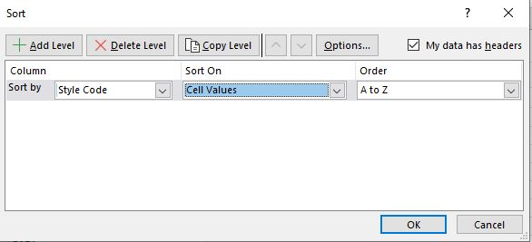

When the selected range includes a header row that should remain in place while the remaining rows are sorted, Excel can detect those column headings and it selects the “My data has headers check box”. That way, it knows to sort the column headings. Under “Column”, I chose “Style Code” in the drop-down list, “Cell Values” for “Sort On”, and left the “A to Z” default option for “Order”. This told me to sort the style code in alphabetical order. When I clicked “OK”, I can see that “B-DB” is the first in the list and “N-CH” is the last.

Now that I sorted my “Style Code” column in alphabetical order, I’m ready to add in my VLOOKUP formula. In cell A9, I typed “G-ID” and pressed “Tab” to go to cell B9. In cell B9, I navigated to the “Formulas” tab, went to the “Function Library” group, clicked on “Lookup & References”, and chose “VLOOKUP”. When I chose “VLOOKUP”, I got a “Function Arguments” pop-up window:

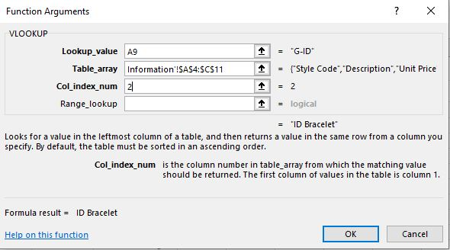

The range includes the value that will be looked up and the corresponding value that I want to show up. The description for the selected item for the value to be looked up is in the second column of the table array. I made my values as an absolute cell reference so that the formula can be copied to the rest of the column in the Phone Order sheet.

Once I clicked “OK”, the VLOOKUP formula showed up in cell B9. When I used the fill-down tool to drag and drop my formula down vertically from cell B9 to cell B19, I get the “#N/A” error. Before I fixed this error though, I typed “12” in cell C9 and “Silver” in cell D9 to complete the information for row 9. In cell E9, I navigated to the “Formulas” tab, went to the “Function Library” group, clicked on “Lookup & References”, and chose “VLOOKUP”. In the “Function Arguments” pop-up window. I set the same criteria as I did for the “Description” column. But this time, I set my “Col_index_num” value to “3” so that Excel can look up the price in the third column of the range. In cell A10, I typed “N-CB”, pressed “Tab” two times, typed “24” in cell C10, and typed “White” in cell D10.

Since I wanted to improve my accuracy while I completed my worksheet, I used data validation. Data validation is a technique, where I can control the data or values that are entered into a cell. In the “Product Information” worksheet, I selected the range from A4 to A11, navigated to the “Formulas” tab, went to the “Defined Names” group, and chose “Create from Selection”. In the “Create from Selection” pop-up window, I left the default option to “Top row”. Then, I clicked “OK” to use “Style Code” as the range name. In the “Phone Order” worksheet, I selected the range from A9 to A18, navigated to the “Data” tab, went to the “Data Tools” group, and chose “Data Validation”. When I clicked on “Data Validation”, I got a “Data Validation” pop-up window:

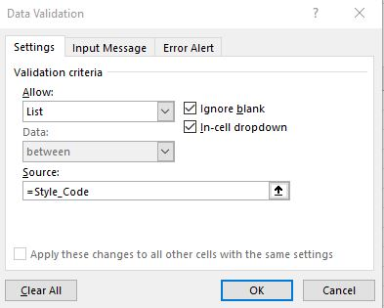

Under “Validation criteria”, I chose the “List” option and set the “Source” to “=Style_Code”. When I clicked “OK”, I got a list arrow that shows in the lower right-hand corner of cell A11. I clicked “B-DB” from the list, pressed “Tab” twice, typed “24” as “Quantity”, pressed “Tab”, and typed “Multi” as “Color”. I repeated this step for A12 with “F-SK” “Item”, “18” as “Quantity”, and “Antique” as “Color”. In cell A13, I typed “H-CK” as “Item”, “18” as “Quantity”, and “Ivory” as “Color”. I deleted rows 14 thru 18, clicked on cell F14, calculated the sum of the “Order Amount” column, and applied the “Total” cell style.

After I completed the data validation, I ran through the auditing process. Auditing is going through a worksheet and checking for errors in formulas. Excel has a group of Formula Auditing features, which have tools from the Formulas tab. Those tools helped me to check my worksheet for errors. In the “Revenue” worksheet, I have green triangles on several cells. Next to those green triangles are the “Trace Error” buttons. The trace errors appear next to the cells, where the formula errors are detected, and a green triangle appears in the upper-left corner of the cell. In cell C9, I clicked on the trace error button and chose “Update Formula to Include Cells”. This included the range from C4 to C8, instead of the incorrect original range from C6 to C8. Then, I used the filldown tool drag the correct formula horizontally across from D8 to G8. In cell H5, I clicked on “Error Checking” and chose “Copy Formula from Above”. This will drag and drop the correct formula down vertically from H4 to H8. I repeated these steps for cell B14. But I chose “Show Calculation Steps”. When I clicked on “Show Calculation Steps”, I got a “Evaluate Formula” pop-up window:

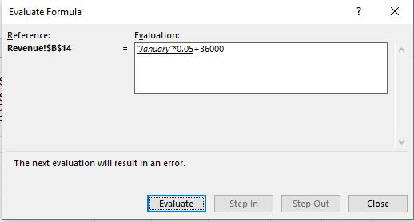

I clicked “Evaluate”. Then in the “Formula Bar”, I edited the formula to change cell B3 to B9.

In cell A24, I typed “Admin Percent”, pressed “Tab”, and typed “2”. In cell B16, I clicked on “Edit in Formula Bar”. I replaced “#REF!” with $B$24. The correct formula needs to be copied across row 16 and it also needs to use an absolute reference so that the 2% Admin Percent will be applied for each month. Then, I used the filldown tool to drag the formula across horizontally from B16 to G16. I repeated this step for column H for the range from H12 to H16.

In cell B24, I set my value to “Percentage”. Then, in cell B19, I entered in the following formula to calculate the revenue/expense for each month:

=B9-17

Then, I used the filldown tool to drag this formula vertically across to cell H19. Next, I formatted cell C20 as a percentage and dragged my value across to cell H20.

Before my report was completed, I had to run through a validation list. A validation list is where I applied data validation and told Excel to circle invalid data. That way, I was able to detect the correct values. To do this, I went to the “Revenue” worksheet, navigated to the “Data” tab, went to the “Data Tools” group, chose the “Data Validation” arrow, and selected “Circle Invalid Data”. Excel found two errors in the “Revenue - by Category” section with “Accessory” and “Bag” and circled those values in red. So, I corrected “Accessory” to “Accessories” and “Bag” to “Bags”. The red circle still didn’t go away. So, I went back to the “Data Validation” arrow and selected “Clear Validation Circles”. Then, I clicked on “Circle Invalid Data” again and this time, I didn’t get any red circles. So, my data is now correct.

My final step was grouping the “Toronto”, “Houston”, “New York”, and “Miami” worksheets together and calculating the sums for the rows and columns in all four worksheets.

So, this is how I used formula auditing and data validation. Hope this tutorial was helpful and I’ll see you in the next one!